

JAVA PROJECT REPORT ON

CREDIT CARD BILLING AND PAYMENT REMINDER SYSTEM

Submitted by

HEMA HARSHITHA V 25BCS219

Under the Guidance of DHARANEESH Technical Trainer
Technical Department, KG College of Arts and Science

Academic Year: 2025 – 2026

APRIL 2026
Semester: I

DECLARATION
I hereby declare that the project entitled “Credit Card Billing and Payment Reminder System” submitted in partial fulfillment of the requirements for the course Java Programming is a record of my original work carried out under the guidance of my trainer.
I further declare that this project has not been submitted previously, either in part or in full, for the award of any degree or diploma.

April 2026 Coimbatore

HEMAHARSHITHA V
(Your Name)

CERTIFICATE
This is to certify that the project entitled “Credit Card Billing and Payment Reminder System” is a bona fide work carried out by HEMA HARSHITHA V, B.Sc Computer Science, KG College of Arts & Science.
This project has been completed under my supervision during the academic year 2025–2026.

Place: Coimbatore
Date:10.04.2026

Submitted for the Viva-Voce Examination held on

10.04.2026

Guide: Head of the Department
(Technical Trainer, KGCAS) (Technical Head, KGCAS)

DHARANEESH
DOODALAN

TABLE OF CONTENTS

S. No. | Topics | Page. No.
1 | Introduction
1.1 | Objective
1.2 | Overview
1.3 | Features
2 | Program Analysis
2.1 | Problem Definition
2.2 | Project Overview
2.3 | Scopes and Limitations
3 | System Design
3.1 | Modules
4 | Methodology
4.1 | Problem Analysis
4.2 | System Design
4.3 | Program Development
4.4 | Testing and Validation
4.5 | Result and Documentation
4.6 | Algorithm
4.7 | Flowchart
5 | Source Code
6 | Input and Output Screens
7 | Discussion and Conclusion
7.1 | Discussion
7.2 | Conclusion
8 | References

ABSTRACT
The Credit Card Billing and Payment Reminder System is a software application designed to assist users in managing their credit card transactions and payments efficiently. In today’s fast-paced digital world, credit cards are widely used for various financial activities. However, many users face difficulties in keeping track of billing cycles, due dates, and outstanding balances, which often results in late payments, penalties, and a negative impact on their credit scores.
This system aims to simplify and automate the process of credit card management by providing a structured platform to monitor transactions, generate billing statements, and send timely reminders for payments. The application records all user transactions during a billing cycle and calculates the total amount due, including any applicable interest or charges. It also tracks important dates such as billing dates and payment due dates, ensuring that users receive alerts before deadlines.
The system is developed using Java programming language and incorporates core programming concepts such as object-oriented principles, collections, exception handling, and file handling. These concepts help in organizing data efficiently and ensuring the reliability of the system. The application is designed with a user-friendly interface so that users can easily navigate through the system and perform operations without difficulty.
One of the key advantages of this system is its ability to reduce financial risks by preventing missed payments and unnecessary penalties. It promotes better financial discipline by encouraging users to stay informed about their credit usage and payment responsibilities. Additionally, the system can be extended in the future to include advanced features such as database integration, mobile notifications, and online payment options.
In conclusion, the Credit Card Billing and Payment Reminder System provides an effective and practical solution for managing credit card activities. It enhances convenience, accuracy, and efficiency in financial management while demonstrating the real-world application of Java programming concepts.

INTRODUCTION

In today’s modern world, credit cards have become an essential part of financial transactions, offering convenience and flexibility to users. People widely use credit cards for shopping, bill payments, travel bookings, and various online transactions. However, with the increasing usage of credit cards, managing payments and keeping track of billing cycles has become a

challenging task for many users. Forgetting due dates, miscalculating outstanding balances, and failing to make timely payments can lead to late payment fees, increased interest charges, and a negative impact on credit scores.
Traditionally, users rely on manual methods such as notes, reminders, or memory to track their credit card bills. These methods are often unreliable and may result in missed payments or financial mismanagement. Therefore, there is a need for an efficient and automated system that can help users manage their credit card activities effectively and ensure timely payments.
The Credit Card Billing and Payment Reminder System is developed to address these challenges by providing a simple and efficient solution for managing credit card transactions and billing information. The system automates the process of recording transactions, calculating the total amount due, and generating billing statements. It also tracks important dates such as billing cycles and due dates and sends reminders to users before the payment deadline.
This system is implemented using the Java programming language and utilizes core concepts such as object-oriented programming, collections, and exception handling. These features ensure that the system is reliable, efficient, and easy to maintain. The application is designed to be user-friendly, allowing users to easily access and manage their credit card information.
The primary aim of this project is to reduce the risk of late payments, improve financial discipline, and simplify credit card management. By automating key processes, the system helps users save time, avoid penalties, and maintain a good credit score. Overall, this project demonstrates how technology can be used to solve real-world financial problems effectively.

  - Objective
The main objective of the Credit Card Billing and Payment Reminder System is to develop a simple and efficient application that helps users manage their credit card transactions and ensure timely payments.
The specific objectives of this project are:
    - To design and develop a system for managing credit card details and transactions.
    - To track billing cycles, billing dates, and payment due dates accurately.
    - To automatically calculate the total amount due, including interest or charges if applicable.
    - To send timely reminders and notifications to users before the payment due date.
    - To reduce late payment penalties and avoid unnecessary interest charges.
    - To provide a user-friendly interface for easy interaction and usage.
    - To improve financial awareness and discipline among users.
    - To demonstrate the implementation of Java programming concepts such as classes, objects, collections, and exception handling.

  - Overview
The Credit Card Billing and Payment Reminder System is a Java-based application designed to simplify the management of credit card transactions and billing activities. The system provides a structured platform where users can record their transactions, monitor their spending, and keep track of important billing information such as billing dates and payment due dates.
The application works by storing details of credit card usage, including purchases and payments made during a billing cycle. Based on the recorded transactions, the system automatically calculates the total outstanding balance and generates a billing statement. It also identifies the due date for payment and sends timely reminders to ensure that users do not miss their payment deadlines.
The system is designed to support multiple credit cards, allowing users to manage all their cards in one place. It provides features such as transaction tracking, automatic bill generation, and reminder notifications. These features help users maintain better control over their finances and reduce the risk of late payments and penalties.
The application is developed using Java programming language and utilizes core concepts such as object-oriented programming, collections, and exception handling. It can be implemented as a console-based application or enhanced with a graphical user interface for better user experience.
Overall, the system aims to improve financial management by providing an efficient, accurate, and user-friendly solution for credit card billing and payment reminders. It also serves as a practical example of applying programming concepts to solve real-world problems.

  - Features
Records and manages credit card transactions.
    - Tracks billing cycle and due dates.
    - Sends reminders before payment deadlines.
    - Automatically calculates total bill amount.
    - Calculates interest and late fees if delayed.
    - Supports multiple credit cards.
    - Provides a simple and user-friendly interface.
    - Helps improve financial management and avoid penalties.

PROGRAM ANALYSIS
Program analysis is the process of understanding the problem and identifying the requirements of the system. In this project, the main problem is the difficulty in managing credit card payments, which often leads to late fees and financial mismanagement.
The system is designed to solve these issues by automating transaction tracking, bill calculation, and payment reminders. It ensures accuracy, reduces manual effort, and improves financial management.
  - Problem Definition
In today’s digital world, many people use credit cards for daily transactions, but managing payments efficiently has become a major challenge. Users often forget billing dates and payment due dates, which leads to late payment fees, increased interest charges, and a negative impact on their credit scores.
Most users rely on manual methods such as notes or memory to track their expenses and payments, which are not reliable. This results in poor financial management and difficulty in handling multiple credit cards.
Therefore, there is a need for an automated system that can track transactions, calculate billing amounts accurately, and send timely reminders to users. The Credit Card Billing and Payment Reminder System is designed to solve these problems by providing an efficient and user-friendly solution.

  - Project Overview
The Credit Card Billing and Payment Reminder System is a Java-based application developed to simplify the management of credit card transactions and billing processes. The system allows users to record their transactions, track billing cycles, and monitor due dates efficiently.
It automatically calculates the total amount due based on user transactions and generates billing statements. The system also sends reminders before the payment due date to help users avoid late fees and penalties.
The application supports multiple credit cards and provides a user-friendly interface for easy usage. By automating billing and reminder functions, the system improves accuracy, reduces manual effort, and helps users maintain better financial discipline.

  - Scopes and Limitations Scope
The Credit Card Billing and Payment Reminder System is designed to help users manage their credit card transactions and payments efficiently. The scope of the system includes:
    - Managing credit card details and transactions
    - Tracking billing cycles and due dates
    - Automatically generating billing statements
    - Sending reminders for upcoming payments
    - Supporting multiple credit cards
    - Improving financial management for users
The system can be used by individual users to monitor and control their credit card usage effectively.

Despite its usefulness, the system has certain limitations:
    - It does not provide real-time integration with banks
    - Limited to basic billing and reminder functionalities
    - Does not support online payment processing
    - Data security features are basic
    - Requires manual input of transactions

SYSTEM DESIGN
System design is the process of planning the structure and components of the system before implementation. It defines how the system will work, how different parts interact, and how user inputs are processed to produce the desired output.
The Credit Card Billing and Payment Reminder System is designed as a simple and efficient application that manages transactions, calculates bills, and sends reminders. The system follows a modular approach, where each module performs a specific function to ensure smooth operation.

  - Modules
The system is divided into the following modules:

- Account & Billing Module
This module is responsible for managing user and credit card details. It stores information such as card number, user details, and transaction records. It also calculates the total bill based on transactions made during the billing cycle.
Functions:
  - Store user and card details
  - Record transactions
  - Generate billing statements
  - Calculate total due amount

This module handles all credit card transactions such as purchases and payments. It records each transaction and updates the balance accordingly.
Functions:
  - Add new transactions
  - Update account balance
  - Maintain transaction history
3. Remainder Module
This module tracks due dates and sends reminders to users before the payment deadline.
Functions:
  - Track billing and due dates
  - Send notifications
  - Alert for overdue payments

This module processes payments made by the user and updates the remaining balance. Functions:
  - Accept payment input
  - Update balance after payment
  - Handle late payment charges
5.Exit Module
This module allows the user to safely exit the system. Functions:

  - Close the application
  - Ensure data is saved properly

METHODOLOGY
Methodology describes the step-by-step process followed to develop the Credit Card Billing and Payment Reminder System. It explains how the problem is analyzed, how the system is designed, implemented, tested, and documented.
A structured approach is followed to ensure that the system works efficiently and meets user requirements. The development process includes the following stages,

  - Problem Analysis

In this stage, the problems related to manual credit card management are identified. Issues such as late payments, calculation errors, and lack of reminders are analyzed.
Based on these problems, system requirements are defined to develop an automated solution that can track transactions, calculate bills, and send reminders.

  - System Design

In this phase, the overall structure of the system is planned. The system is divided into modules such as:
    - Account & Billing Module

    - Transaction Module

    - Reminder Module

    - Payment Module

The design ensures that each module performs a specific function and interacts properly with other modules.

  - Program Development

In this stage, the system is implemented using the Java programming language. The following activities are performed:
    - Creating classes and objects

    - Writing logic for transaction handling

    - Implementing bill calculation

    - Developing reminder functionality

    - Handling user inputs

Core Java concepts such as loops, conditional statements, and methods are used.

  - Testing and Validation

The system is tested to ensure that it works correctly. Different test cases are used to check:

    - Transaction recording

    - Bill calculation accuracy

    - Reminder functionality

    - Error handling

This ensures that the system produces correct and reliable results

  - Result and Documentation

After successful testing, the system generates accurate billing statements and reminders. The results are documented properly, including system design, working process, and outputs
  - Algorithm

Start the program

- Enter user and card details

- Add transactions

- Calculate total bill

- Generate billing statement

- Send reminder

- Process payment

- Display final result

- End

  - Flowchart
Students should draw a flowchart showing program flow. Example flow:
Start → Input Details → Add Transactions → Calculate Bill → Send Reminder → Payment
→ End

SOURCE CODE

double total = balance; double interest = total * 0.02;
double finalAmount = total + interest;

- INPUT AND OUTPUT SCREENS
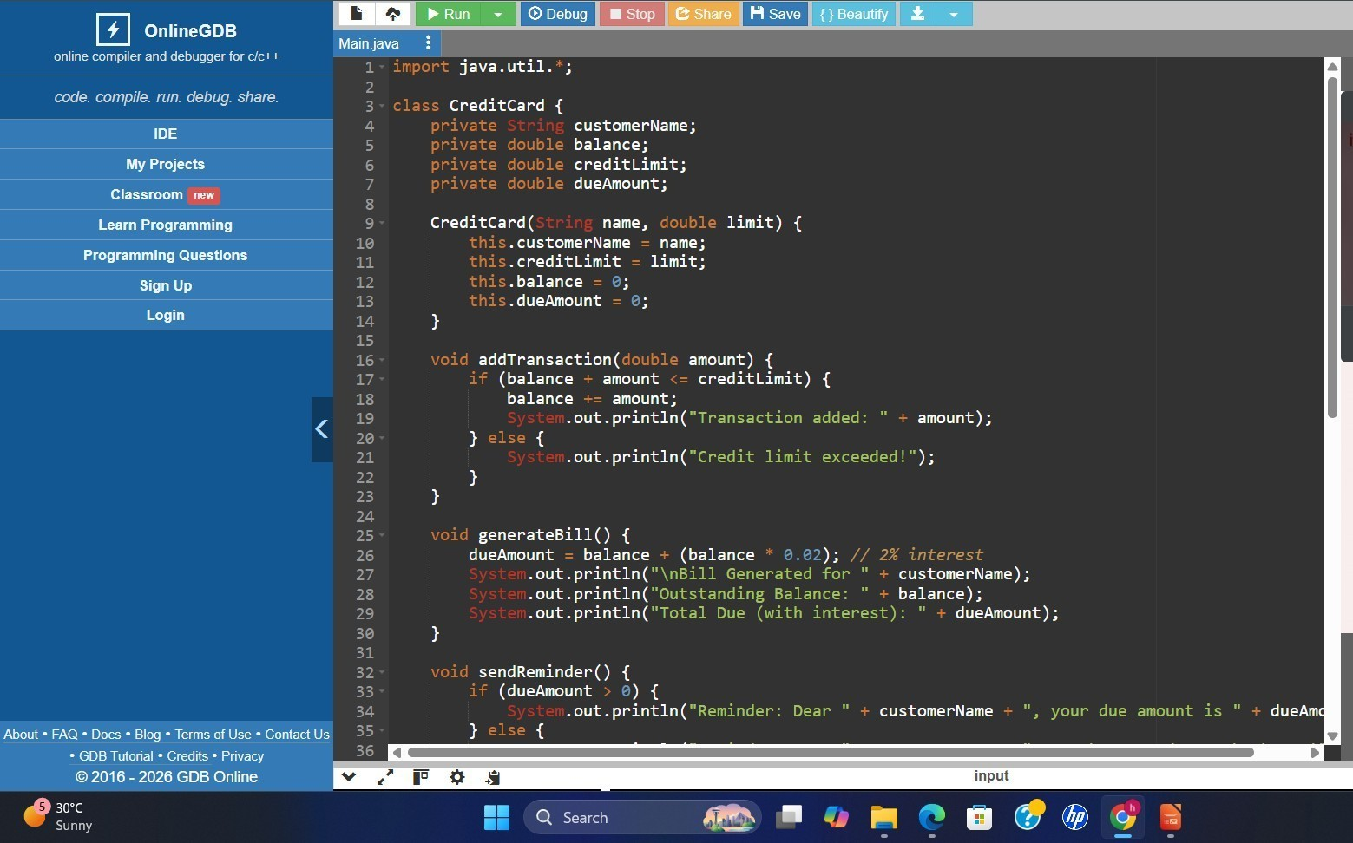

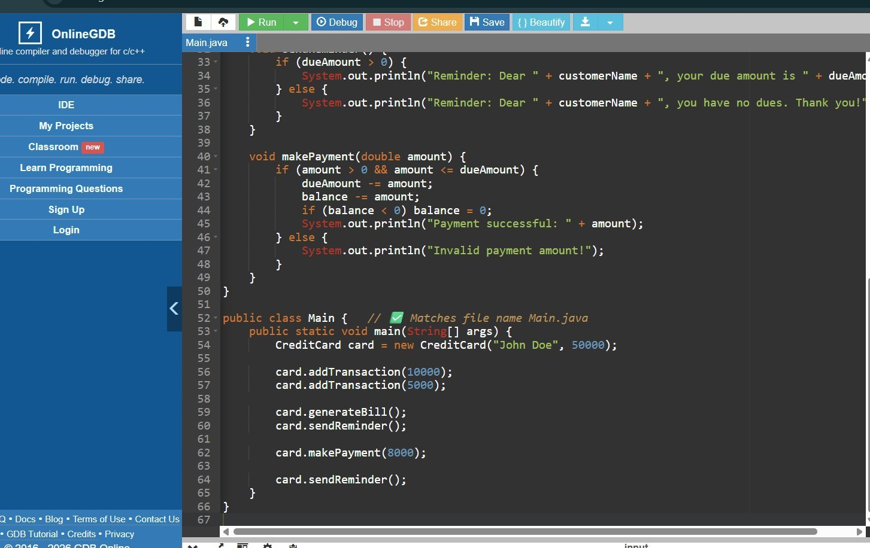

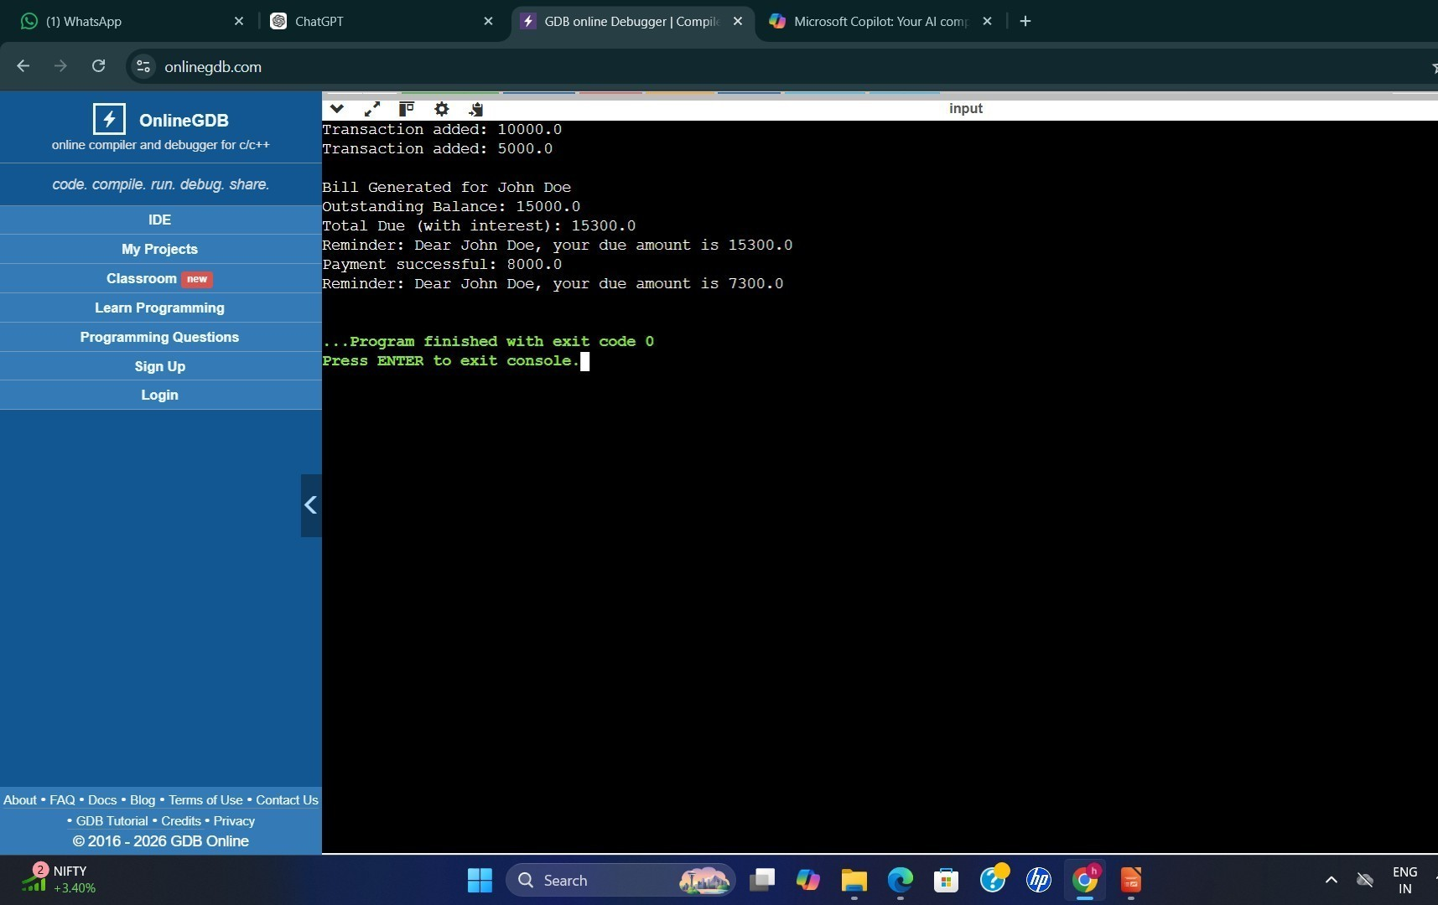

- DISCUSSION & CONCLUSION

REFERENCES

The following resources were used during the development of this project:
Books
- Herbert Schildt, Java: The Complete Reference, McGraw-Hill Education
Websites
https://www.oracle.com/java
https://www.geeksforgeeks.org https://www.w3schools.com https://www.javatpoint.com

